CENWP-OD-B 28MAR2023

MEMORANDUM FOR THE RECORD

SUBJECT: 23BON013 MFR BON FG6-18 Diffuser Hatch Failure

At approximately 0830 on 25MAR2023 Project Biologists discovered very turbulent water near Cascades Island diffuser FG6-18 in the Cascades Island Entrance Bay (Figure 1). BON adjusted flow through FG6-18 by opening FG6-18 and closing FV5-4 from 85-90% open to 40% open. Water flow from FG6-18 remained turbulent. Project Biologists suspected a blown grating above the diffuser pit.

An ROV inspection occurred on 28 March from 0800 until 0820. The ROV inspection required closing FV5-4 and FV5-3, which resulted in head differential at the entrance going below the FPP criteria of 1’ – 2’. Attraction flow was restored at 0820.

The FG6-18 diffuser chamber access hatch was blown out of place (Figures 2 and 3). The Project is planning for the removal of the hatch, via ROV, on 30 March. Repairs will follow as soon as possible. BON Project Fisheries and Operations will continue to monitor the fishway conditions closely.

Species –minimal fish passage at Bonneville at this time (03/25/23 fish count numbers: 8 Adult Spring Chinook, 1 Jack Spring Chinook, 72 Steelhead)
Future and Preventative Measures – fix and/or replace hatch hole cover and continue close monitoring
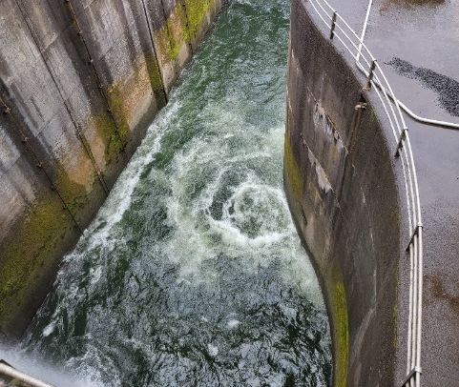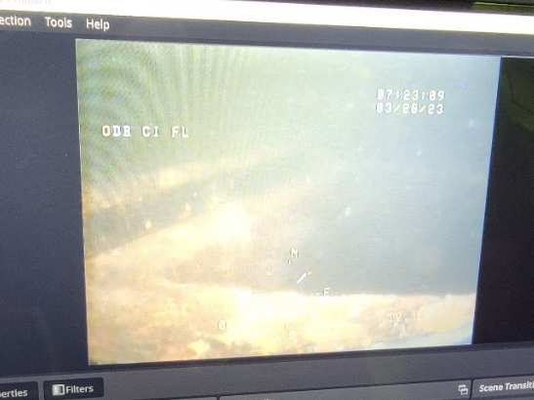
Figure 1. Turbulent water in CI Entrance. Figure 2. CI FG6-18 diffuser missing hatch.
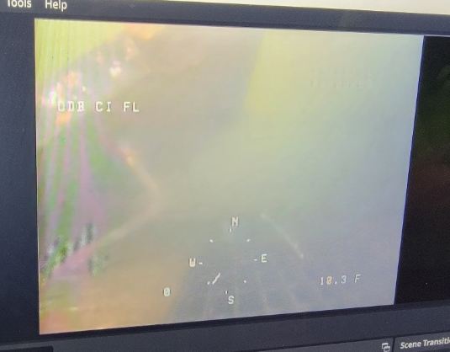
Figure 3. CI FG6-18 diffuser dislodged hatch.

Update –
-----Original Message-----
From: Derugin, Andrew G CIV (USA) <Andrew.G.Derugin@usace.army.mil>
Sent: Thursday, March 30, 2023 6:09 PM
Subject: RE: FPOM: Official Coordination - 23BON013 MFR
We got an ROV in there today and retrieved the broken hatch. A new one will be made and installed by our newly formed dive team (j hill) on Wednesday of next week. Outage today ~ 1 hour at 1100.

Comments from others -
-----Original Message-----
From: Tom Lorz <lort@critfc.org>
Sent: Friday, April 07, 2023 12:31 PM
To: Mackey, Tammy M CIV USARMY CENWP (USA) <Tammy.M.Mackey@usace.army.mil>
Subject: [Non-DoD Source] Re: FPOM: Official Coordination - 23BONO015 MFR FG6-18 hatch replacement

thanks for the update and appreciate getting the work done, wished they could have gotten the wires done at the same time.......but we are never that lucky.

tom

Sincerely,
Bonneville Project Fisheries

